SEO PowerSuite product review

Many of you know that there are quite a lot of SEO tools on the market, and it’s really hard to choose the one that will help you with your daily site promotion activities.
Recently I’ve come across a rather decent toolset, SEO PowerSuite (link to http://YOURID.powersuite.hop.clickbank.net, replacing YOURID with your Clickbank username ), which I’ll be reviewing below.
For a start, though I’ve got to know SEO PowerSuite quite recently, the software is not new. It’s been on the market for 9 years now, so many people have been successfully using it for years to promote their sites online. Quite a term to prove the software is a strong player!
SEO PowerSuite is a complete toolset for search engine optimization. It consists of 4 tools: Rank Tracker, WebSite Auditor, SEO SpyGlass and LinkAssistant. These tools can be used separately, but they definitely deliver best results when applied together, as a system.
I’ll be describing the four tools within SEO PowerSuite one by one below.

Rank Tracker
Rack Tracker is my favorite tool in the whole bundle. Basically, it is keyword research and rank checking software, yet it has so many hidden gems that you can’t get enough of it.
Rank Tracker features:
- keyword research with 17 advanced methods
- rank checks in 325 search engines
- unlimited keywords, unlimited sites
- traffic stats next to ranking data
- local search results
- universal search results
- fabulous reporting
Basically, here’s how your Rank Tracker’s workspace will look like:
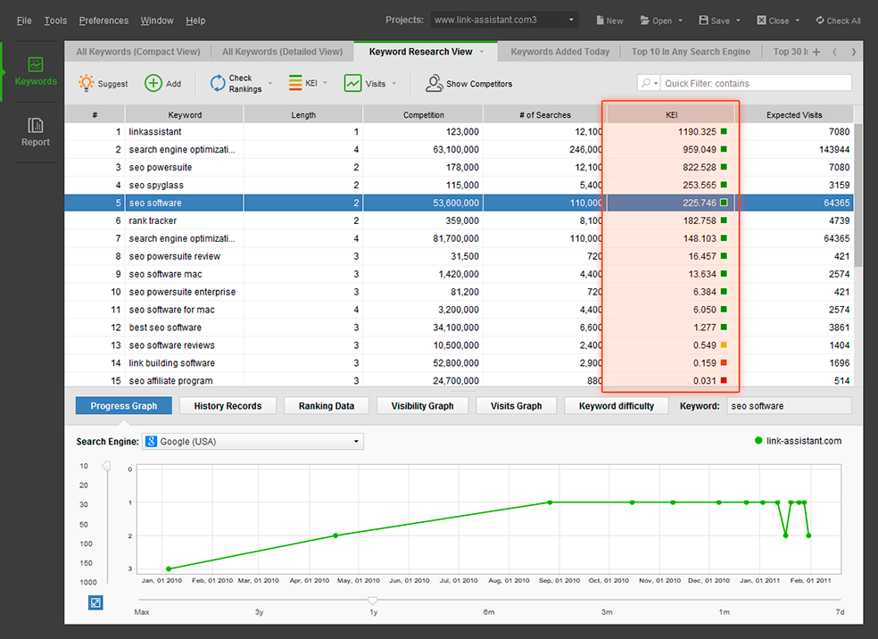

As you can see, there’s a special metric, Keyword Efficiency Index (KEI), which helps you figure out how good your keywords are.
Along with the KEI data, you can see how many organic Visits you can expect if you rank for this keyword. This way, you won’t go blind with your organic strategy but rather know what to expect from your SEO efforts.
The best part is you can watch your ranking progress for a specific keyword with a neat graph at the bottom of your workspace.

WebSite Auditor
WebSite Auditor is an indispensable tool for onpage SEO and site audit. It also does a lot of amazing things to make sure that your site is friendly to both users and search engines.
WebSite Auditor features:
- checks if your website can be crawled and indexed
- points to redirect issues and site encoding problems
- finds all broken links
- lets you polish on-page ranking factors
- checks how well the content is optimized for SEO
- manages sitemaps, robots.txt
- creates professional site audit reports
Whether you site is old or new, well- or poorly-optimized, you absolutely need to run a health check for it with WebSite Auditor. The software will point out a huge number of issues to you. And when you have all these issues fixed, your site will work like a flawless system, which will also contribute to high rankings.

SEO SpyGlass
SEO SpyGlass is a powerful link research and link analysis tool. Unlike WebSite Auditor that handles the on-page side of things, SEO SpyGlass covers a variety of off-page aspects.
SEO SpyGlass features:
- finds all external links a website has
- gets data from hundreds of external data sources and a powerful internal link database
- collects dozens of quality metrics for each link it finds
- alarms you about dangerous links
- generates professional backlink reports
As the name implies, site promoters use SEO SpyGlass to spy on their competitors and replicate their best SEO moves. It is as simple as that: with SEO SpyGlass you find out which links make your competitors powerful and follow their footsteps. I’m applying this strategy, and should testify it works.
Additionally, SEO SpyGlass can be used to keep track of links to your own sites. In the era of Pandas, Penguins and other quality updates from Google this becomes particularly important. In fact, with SEO SpyGlass you get a full list of links your website has and can see which ones are harmful, so you could get rid of them.

LinkAssistant
Last but not least, LinkAssistant is a link building and link management tool. It is perfect for link outreach and keeping all your link stats and link contacts in one place.
LinkAssistant features:
- link suggestions with 6 powerful methods
- immense outreach capabilities, including search for contacts and an in-built email client
- link stats
- link verification
- link building reports
Apparently, LinkAssistant has been the first tool in the SEO PowerSuite series, and the developers created it 9 years ago, back then it was meant for the established SEO tactics of the day. Yet, it can still be used now to keep track of all your link contacts in one place and see if the links are still in place. Quite handy!

Some general thoughts about SEO PowerSuite
Design
SEO PowerSuite is very neatly designed. The button layout echoes the sequence of your SEO activities, which makes the software a no-brainer.
Here’s one more screenshot to show you how nice and SEO professional-friendle the software is:
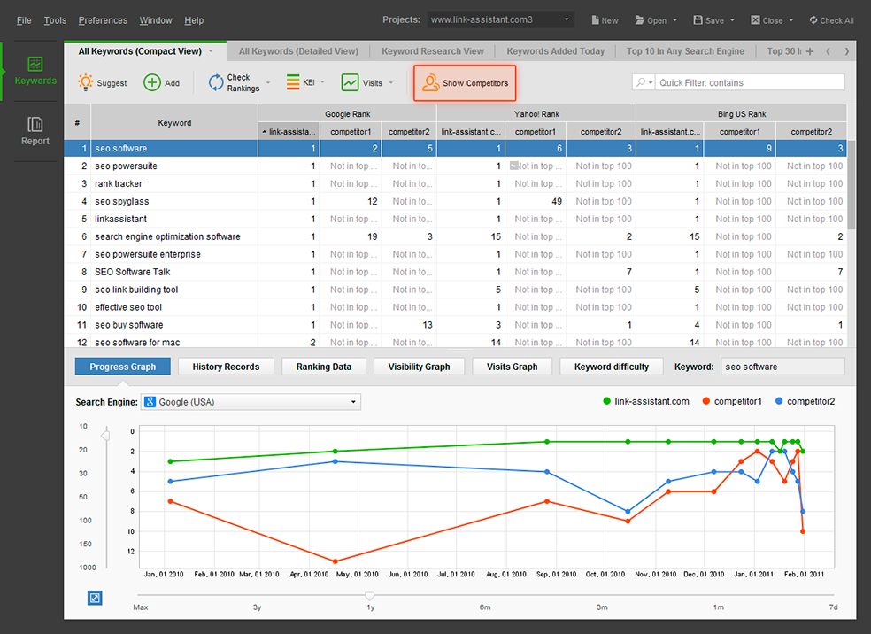

Desktop
Unlike many competitors, SEO PowerSuite is a desktop tool, which gives you a number of advantages:
- in terms of security, you have all your data stored right on your computer, so you don’t depend on 3rd party servers or risk losing valuable SEO data
- in terms of data volumes, you can get way more with desktop software compared to online tools
If you’re a Mac user, you’ll be happy to find out that SEO PowerSuite is compliant with Mac OS X. Being cross-platform, the software also works on Windows and Linux:
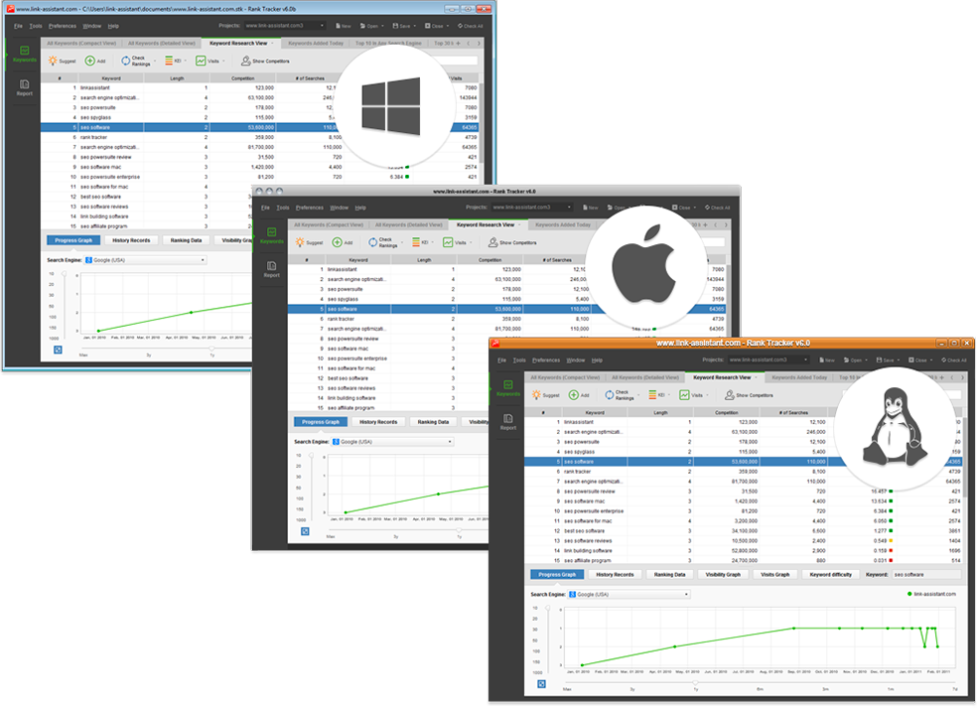

Final words
As you can see, SEO PowerSuite is a fantastic tool for making your sites rank higher in Google search results. I personally use and recommend it, and you can get your own copy at http://YOURID.powersuite.hop.clickbank.net.

